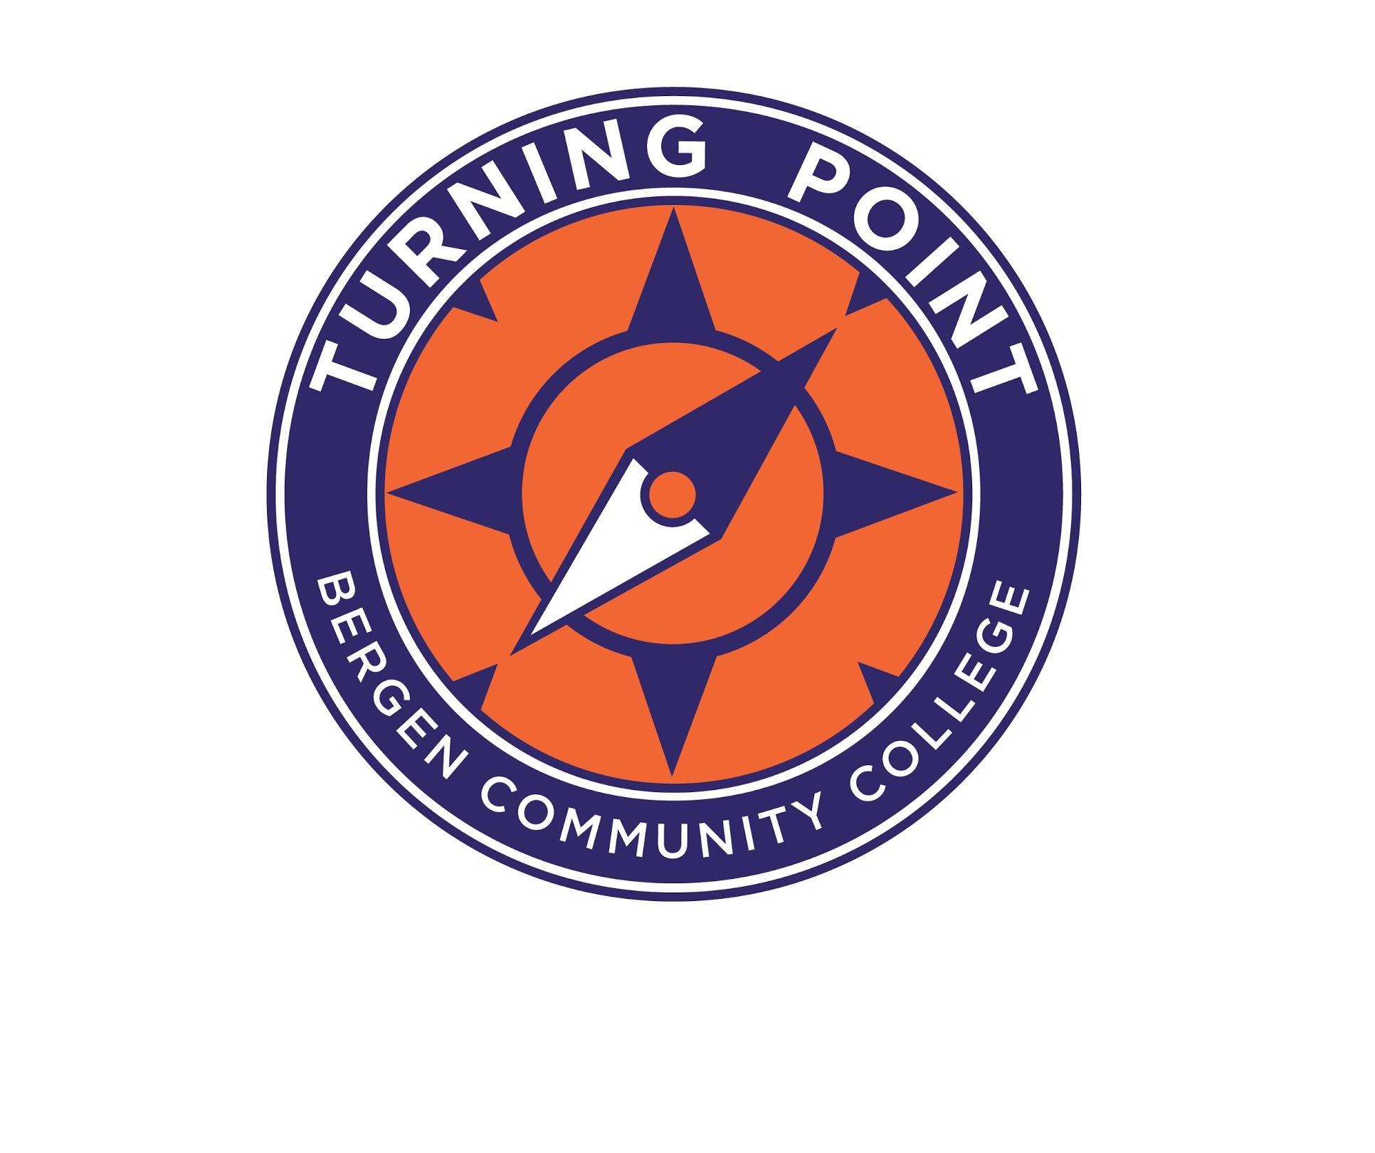

Turning Point Program
Student Application

Year: ________

APPLICATIONS ACCEPTED BY MAIL ONLY

Bergen Community College
Turning Point Program
Room L121
Pitkin Education Building
400 Paramus Road
Paramus, NJ 07652
201-493-4087
turningpoint@bergen.edu

ALL APPLICATIONS ARE REVIEWED BY THE ADMISSIONS COMMITTEE

Application for Admission
Applicants are to complete all the following pages of the Application Packet to be considered for the Turning Point Program. Once the packet is submitted and received, it will be reviewed by the Admission Committee. Applicants that are found eligible will be contacted by phone to schedule an interview with the Admission Committee. Upon completion of the Admission interview, applicants who are being moved forward in the admission process will be contacted to participate in a “Shadowing Day” event that provides applicants the opportunity to participate in classes and activities with our current Turning Point students. The interview and shadowing day process is meant to ensure the Turning Point Program is an appropriate fit for the applicant. Applications for the Fall 2020 semester are due by December 31, 2019.
Please note, due to space limitations of the Program, not all students who meet the criteria for admission will be accepted as there is a maximum of 16 spaces available.
Each applicant should complete the Application Checklist as independently as possible. The applications can be typed or handwritten and must include all information.
Two Letters of Recommendation must be included with the application packet. Each recommendation must be in a sealed envelope with signature across the seal.
Applications not containing the mandatory information and documents will not be reviewed.
Application Checklist
- ____ Turning Point Student Application
2. ____ Current Photo of Applicant
3. ____ Student Questionnaire to be completed by the applicant
4. ____ Parent/Guardian Information to be completed by parent/guardian
5. ____ Emergency Contact/Medical Information Form
6. ____ Release/Exchange of Information Form
7.____ Evaluations – MANDATORY – most recent and relevant evaluations that best reflect the individual's current academic, social, and emotional needs conducted no more than three to five years for school purposes and/or by an outside/private provider – Educational and Psychological/ Behavioral evaluations must be included.
8. ____ Academic Performance Documentation – most recent individualized education plan (IEP), official high school transcripts or any records from attended post-secondary program.
9. ____ Two Letters of Recommendation – to be completed by a non-family member that has known the applicant for one or more years. Letters must be submitted using the Recommendation Form (pg. 16 & 17 of the application) and returned with the application packet as directed on the form. NOTE: Letters of Recommendation must be included in a sealed envelope with signature across the seal.
Applicant’s Signature: _______________________________________ Date: _____________________
Application for Admissions Procedure
Records submitted must support and clearly state that the applicant has an Intellectual Disability in order to be considered for the Turning Point Program. The application packet is reviewed as a whole by the Admission Committee to determine if the applicant meets the eligibility requirements as well as ensure Turning Point is a good fit for the applicant. If students are deemed eligible, they will be invited to take part in an interview with the Admission Committee where they will be asked to demonstrate basic literacy skills (reading and writing). Upon completion of the Admission interview, applicants who are being moved forward in the admission process will be contacted to participate in a “Shadowing Day” event that provides applicants the opportunity to participate in classes and activities with our current Turning Point students.
The Turning Point Program is a comprehensive program of study for unique learners who are highly motivated young adults whose “disability” is characterized by significant limitations both in intellectual functioning and in adaptive behavior as expressed in conceptual, social, and practical adaptive skills” *(AAIDD definition). Applicants will have received extensive special education services in their secondary schools and would have considerable difficulty succeeding in a traditional college degree program.
Applicants must have a strong desire to become an independent adult, and demonstrate sufficient emotional stability and maturity to participate successfully in the program.
Please note, due to space limitations of the Program, not all students who initially meet the criteria for admission will be accepted.
Admission is based on the following criteria:
- Applicants must be between the ages of 18-30 at the start of the program.
- The applicant must have significant limitations in both intellectual functioning and in adaptive behavior, which covers many everyday social and practical skills. (AAIDD definition of Intellectual Disability)
- The applicant must have sufficient emotional and independent stability to participate in all aspects of the program coursework and campus environment.
- The applicant must demonstrate the ability to accept and follow reasonable rules and behave respectfully towards others. Note: The program does not have the personnel to supervise students with difficult and challenging behaviors or dispense medications.
- The applicant must demonstrate the desire to attend Turning Point and adhere to the policies regarding attendance and participation in the program.
- The applicant must have the potential to successfully achieve his/her goals with the context of the Turning Point Program’s content and setting.
- Applicant must have been identified with an intellectual disability while active in the K-12 system.
Please do not call about the status of your application, as we will not be able to provide this information for you over the phone. Applicants will receive updates based on program eligibility and if applicable, admission status via mail.
*Idea 2004 requires that, when a student graduates or reaches age 21 and is no longer eligible for special education and related services, a summary of the student’s academic achievement and functional performance must be provided to the student. (SOP) The summary must include recommendations on how to assist the student in meeting the student’s post-secondary goals. Such summaries are required for students who graduate or turn 21 on or after July 1, 2005.
Please complete all sections of the application. If you need assistance, it is acceptable for the applicant to receive support. We request all sections be completed in order to assist us in determining this applicant’s admissibility to the program. All information is confidential and will not be shared with any outside agencies unless a written agreement is provided by the applicant. You may attach additional information and pages for writing space if needed.
STUDENT INFORMATION
Last Name First Name MI | Home Phone
Home Address | Birth Date
City State Zip Code | Cell Phone
E-Mail Address

Student receives support from: (please check those that apply)
____ Supplemental Security Income (SSI)
____ Social Security Disability Insurance (SSDI)
____ Division of Developmental Disabilities (DDD Self Directed Supports)
____ Medical Assistance
____ Division of Vocational Rehabilitation Services (DVRS)
____ Special Education Services (IDEA funding)

FAMILY INFORMATION
Student lives with:
____ both parents ____ Mother ____ Father ____ Guardian(s) ____ other
Mother/Guardian: Last Name First Name MI | Home Phone
Address | Occupation/ Employer
City State Zip Code | Work Phone
Email Address | Cell Phone
Father/Guardian: Last Name First Name MI | Home Phone
Address | Occupation/ Employer
City State Zip Code | Work Phone
Email Address | Cell Phone
Siblings:
Name | Age

EMERGENCY CONTACT INFORMATION: IN CASE OF AN EMERGENCY, PLEASE CONTACT:
NAME: __________________________________________ AT __________________________
EDUCATION HISTORY
Schools Attended (Name, City, State) | Years attended | Reason for Leaving

Did you receive a high school diploma or equivalent? No Yes
From (school) _________________________________________ Date ________________
Please describe your academic strengths and weaknesses.
________________________________________________________________________________________________________________________________________________________________________________________________________________________________________________________________________________________________________________________
What type of accommodations help you learn best? (e.g. small groups, extra time)
________________________________________________________________________________________________________________________________________________________________________________________________________________________________________________________________________________________________________________________
In the following areas, please describe skills you would like to learn?
- Independent living: ______________________________________________________
- Liberal Studies (Art, Literature): ____________________________________________
- Social/recreational /leisure: ________________________________________________
- Employment: ___________________________________________________________
Have you participated in general education classes in your past school? Yes No
If yes, list subjects _____________________________________________________________
Have you have any accommodations for your general education classes? Yes No
If yes, what kind? ______________________________________________________________

EMPLOYMENT HISTORY
Please complete the following.
Note: prior work experience is not a requirement for admission into this program
Name of Business/Employer | Paid or Unpaid | Job Responsibilities | Reason for Leaving | Amount of time at job

Are you currently participating in a work experience? Is this experience paid or unpaid?
____________________________________________________________________________________________________________________________________________________________
Are you currently participating as a volunteer?
____________________________________________________________________________________________________________________________________________________________
What work experiences do you have an interest in or enjoy?
____________________________________________________________________________________________________________________________________________________________

TRANSPORTATION
What type of transportation do you plan to utilize if you were to attend the Program?
____________________________________________________________________________________________________________________________________________________________
Are there any limitations, support needs or related issues to transportation? (Please list)
____________________________________________________________________________________________________________________________________________________________

MEDICAL HISTORY
Please give a brief description of your medical history including any disability diagnosis that you may have: __________________________________________________________________________________________________________________________________________________________________________________________________________________________________________
Please list any significant medical or physical conditions that may impact your participation in classroom, social, or recreational activities on campus, including severe allergies: __________________________________________________________________________________________________________________________________________________________________________________________________________________________________________
Please list any current medications and their purpose: __________________________________________________________________________________________________________________________________________________________________________________________________________________________________________
Note: If the applicant must take medications while on campus, he/she must be independent in administering his/her medications. Bergen Community College does not have the personnel or facility to administer medications. This is not included in any of the program or college services. The same is to be said about Occupational, Physical, Speech, and (consistent) Mental Health therapies. These services are not included in the program.
Do you currently receive private therapeutic services? Physical therapy, occupational therapy, outpatient counseling/psychiatry, speech therapy, behavioral therapy?
If so, please indicate which services: __________________________________________________________________________________________________________________________________________________________________________________________________________________________________________
Are you independent in self-care such as toileting, and basic hygiene? Yes No
Please provide any other medical information that you feel would be important regarding your participation in this program, please specify. ______________________________________________________________________________________________________________________________________________________________________________________________________________________________________________________________________________________________________________________________________________________________________________________________________

Bergen Community College treats and regards all written documentation obtained to verify a disability and plan for appropriate services as well as all documented services and contracts with the Office of Student Support Services as confidential. However, it may be necessary for our staff to exchange some information about you with the Bergen Community College faculty and staff in order to provide you with educational opportunities and experiences on and off campus. This exchange will occur only with your written permission, as given in this document below, and with the understanding that only information necessary for the purposes of accommodation and academic progress will be communicated.
Name _________________________________________ Date ______________________
I give permission to exchange information about me to the following offices/individuals checked below:
____ School District(s) _________________________________________________
____ DVR Office
____ DDD Office
____ Admissions Office
____ Counseling Office
____ Course Instructors
____ Financial Aid Office
____ Parents/Guardians
____ Registrar’s Office
____ Tutor
____ Other _____________________________________________________________
I hereby give permission for the Turning Point Program at Bergen Community College the right to use my photograph and/or quotes and videotapes of me for public relations and/or training purposes.
Student Signature __________________________________________ Date ____________________

Parent/Guardian Signature __________________________________ Date ____________________

PERSONAL SUPPORT INVENTORY
To be filled out by: Parent/Family/Guardian/Support person
Independent Living Skills | 1  (Requires complete assistance) | 2  (Needs moderate assistance) | 3  (Needs some assistance) | 4  (Needs minimal assistance) | 5  (Completely Independent)
Negotiating/finding way around campus environment
Ordering and purchasing from a restaurant/cafeteria/ store
Handling personal affairs: laundry, light cooking, cleaning, managing personal belongings
Interpersonal Skills: Ability to relate to others
Asks for help, clarification, or questions
Use of judgment skills in an emergency
Emotional: Copes with stress
Adjusts to new situations

Social Skills and Communication | 1  (Requires complete assistance) | 2  (Needs moderate assistance) | 3  (Needs some assistance) | 4  (Needs minimal assistance) | 5  (Completely Independent)
Communicating needs in an appropriate manner
Engaging in appropriate social interaction
Using pay phone, cell phone, email

Academic Skills | 1  (Requires complete assistance) | 2  (Needs moderate assistance) | 3  (Needs some assistance) | 4  (Needs minimal assistance) | 5  (Completely Independent)
Handling money: counting change/bills, understanding values, using checkbook, staying within budget
Math skills:
Approximate Grade Levels:
____ Addition
____ Subtraction
____ Multiplication
____ Division
Reading and writing skills: Approximate Grade Levels:
___ Reading
___ Writing
___ Listening
___ Comprehension
Computer Skills: Word processing, Internet
Motivation to learn and persist on new tasks
Knows and can verbalize and/or write personal information: name, address, phone, SSN, etc.
Ability to follow verbal directions
Ability to follow written directions
Ability to keep a daily schedule with due dates and assignments

Has applicant utilized any assistive technology? If yes, what?
__________________________________________________________________________________________________________________________________________________________________________________________________________________________________________

Please list/discuss any physical, intellectual, social or emotional conditions that may need to be considered when planning a postsecondary experience.
______________________________________________________________________________________________________________________________________________________________________________________________________________________________________________________________________________________________________________________________________________________________________________________________________________________________________________________________________________________________________________________________________________________________________________________________________________________________________________________________________________________________________________________________________________________________________________________________________________________________________________________________________________________________________________________________________________________________________________________________________________________________________________________________________________________________________________________________________________________________________________________________________________________________________________________________________________________________________________________________________________________________________________

STUDENT QUESTIONNAIRE
This section is to be filled out by the potential student and additional pages may be included.
This is an excellent opportunity to show off your writing skills, your critical thinking skills, and your creativity!
Why would you like to attend the Turning Point Program at Bergen Community College?

What topics are you interested in learning about in college courses?

What do you want to learn that you haven’t learned in high school?

What type of job/career would you like to have after graduation?

What do you enjoy doing in your free time? Any specific hobbies you enjoy?

Do you spend time with friends outside of school? YES NO
What do you like to do with your friends?

Please list two goals you have for your future and explain how the Turning Point Program would help you achieve those goals if accepted.

Please use this page to provide us with any additional information about yourself that you wish to share.
__________________________________________________________________________________________________________________________________________________________________________________________________________________________________________________________________________________________________________________________________________________________________________________________________________________________________________________________________________________________________________________________________________________________________________________________________________________________________________________________________________________________________________________________________________________________________________________________________________________________________________________________________________________________________________________________________________________________________________________________________________________________________________________________________________________________________________________________________________________________________________________________________________________________________________________________________________________________________________________________________________________________________________________________________________________________________________________________________________________________________________________________________________

Turning Point Program
Recommendation Form

_______________________________________________________________
(Applicant name)
The above named individual has applied for admission to the Turning Point Program at Bergen Community College. The program serves to provide young adults with intellectual disabilities an inclusive college experience that will further their academic, vocational, social and independent living skills. Please answer the following questions to the best of your ability. If you have any further questions please contact the Turning Point Program at 201-493-4087. Please Note: Letters of Recommendation must be included in a sealed envelope with signature across the seal.
Your Name: ________________________________________________________________
Title: ______________________________________________________________________
Address: ___________________________________________________________________
City: ______________________________________________________________________
State: ______________________________________________________________________
Zip Code: ___________________________________________________________________
Phone:______________________________________________________________________
Organization:________________________________________________________________
Email Address: ______________________________________________________________
How long have you known the applicant, and in what capacity?

Do you feel the applicant would benefit from the program? ___Yes ___No
Why or why not?

Does the applicant have any behaviors that would interfere with their ability to participate in the program? Yes No Comments:

Describe the strengths that the applicant has that will make him/her a strong applicant for the Turning Point.

Turning Point Program
Recommendation Form
_______________________________________________________________
(Applicant name)
The above named individual has applied for admission to the Turning Point Program at Bergen Community College. The program serves to provide young adults with intellectual disabilities an inclusive college experience that will further their academic, vocational, social and independent living skills. Please answer the following questions to the best of your ability. If you have any further questions please contact the Turning Point Program at 201-493-4087. Please Note: Letters of Recommendation must be included in a sealed envelope with signature across the seal.
Your Name: ________________________________________________________________
Title: ______________________________________________________________________
Address: ___________________________________________________________________
City: ______________________________________________________________________
State: ______________________________________________________________________
Zip Code: ___________________________________________________________________
Phone:______________________________________________________________________
Organization:________________________________________________________________
Email Address: ______________________________________________________________
How long have you known the applicant, and in what capacity?

Do you feel the applicant would benefit from the program? ___Yes ___No
Why or why not?

Does the applicant have any behaviors that would interfere with their ability to participate in the program? Yes No Comments:

Describe the strengths that the applicant has that will make him/her a strong applicant for the Turning Point.

